**1) Administration**

**Icon not given in the list:**

  
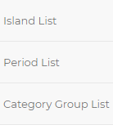

**2) Home**

**It provide a facility to add role and permission but it is separately define in list to add both**



**3) Add user:**

**i.) Icon not given**



**ii) Placeholder value wrong**

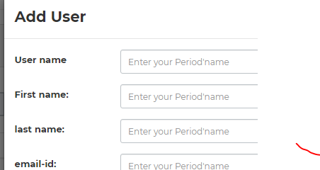

**iii) in input box character limit not set or not apply validation in a form**

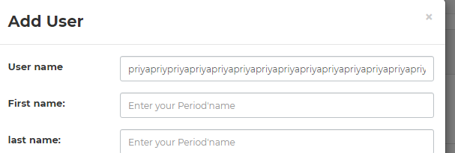

**iv) if we add new user and fill form but not save it again show previous add user information**

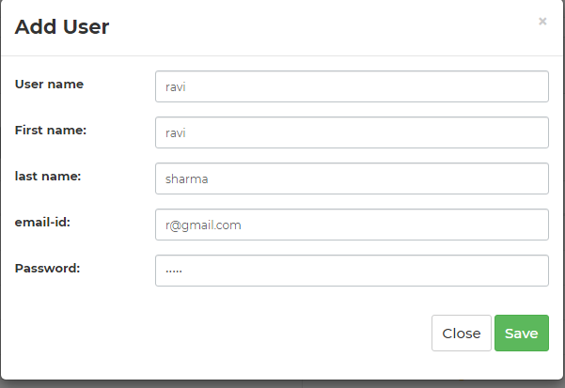

**v) search operation failed on search user**



**vi) print a message in alert box are u really want to delete this and then delete**

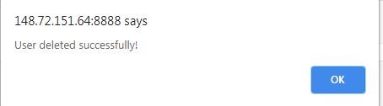

**4) Add permission**

**(i) in input box character limit not set or not apply validation in a form**

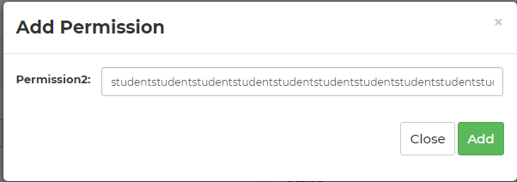

**ii) if we add permission and fill form but not save it and again add permission it show previous data if we add new permission**

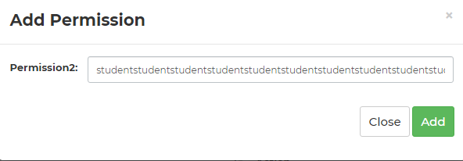

**5) Role list**

**(i) in input box character limit not set or not apply validation in a add role form**

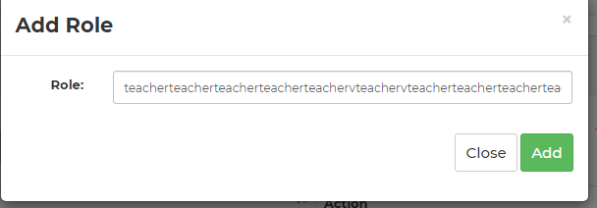

**ii) if we add permission and fill form but not save it and again add permission it show previous data if we add new permission**



**6) Category list**

**(i) in input box character limit not set or not apply validation in a add category form**

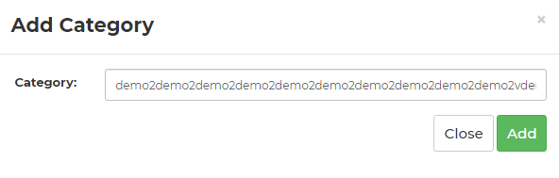

**ii) if we add category and fill form but not save it and again add category it show previous data if we add new category**



**7) Add item**

**(i) in input box character limit not set or not apply validation in a add category form**

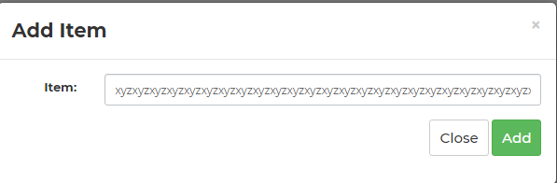

**ii) if we add item and fill form but not save it and again add item it show previous data if we add new item**



**iii) search operation failed on search user**

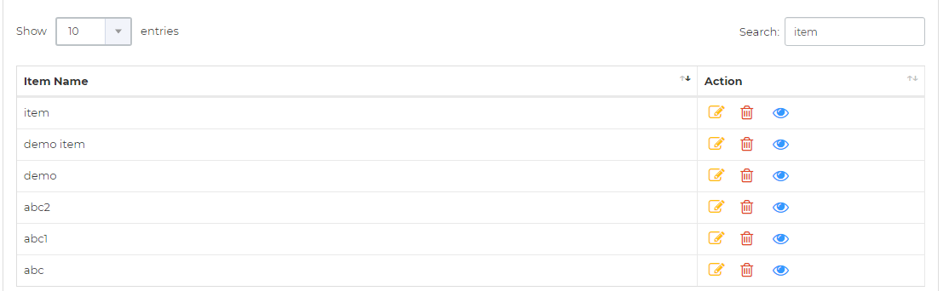

**8) Retailer list**

**(i) in input box character limit not set or not apply validation in a add Retailer form**

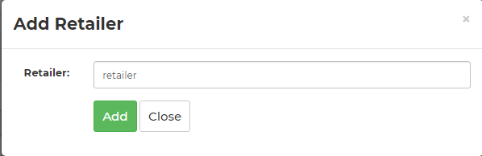

**ii) if we add Retailer and fill form but not save it and again add retailer it show previous data if we add new Retailer**

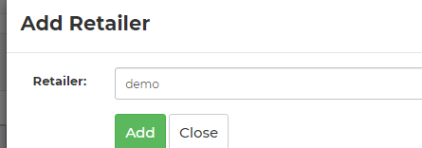



**Same error in other list like**

**i) input box character limit not set or not validation apply**

**ii) if we add something and not save and add new it show previous data**

**iii) search failed if we save data to list name**

* **Allow Type List**
* **Supplier List**
* **Brand List**
* **Island List**
* **Period List**
* **Category Group List**

**9) Login page**

i) Spelling incorrect id



ii) character limit not specified and not validation if empty user text field empty

iii) show a message login failed only not specific message for empty user and password

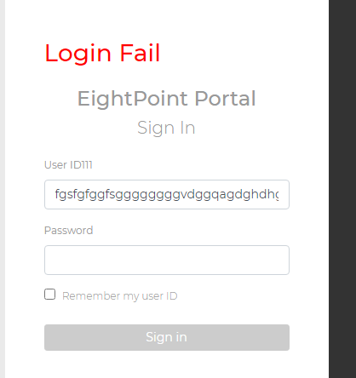

iv)validation not apply on password field

v) and also used a password icon

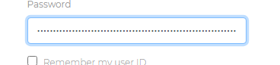

**vi) Forget password link not working and not visible proper**



**10) On Dashboard**

**i) image icon not show**

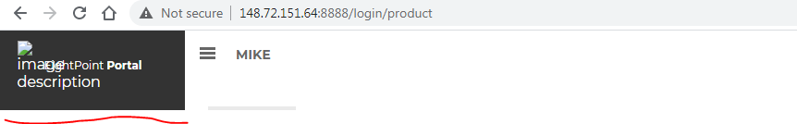

**ii) create new not working**



**11) Product**

**i) batch action not working**



**ii) display filtering not working**



**iii) Action-> Export dealsheet not working**

**iv) Pagination is not working**

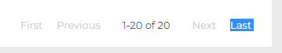

**v) All button are not working**



**vi) Privacy, security, term of services link not define back to**

**v) validation not apply on edit product page empty input box**

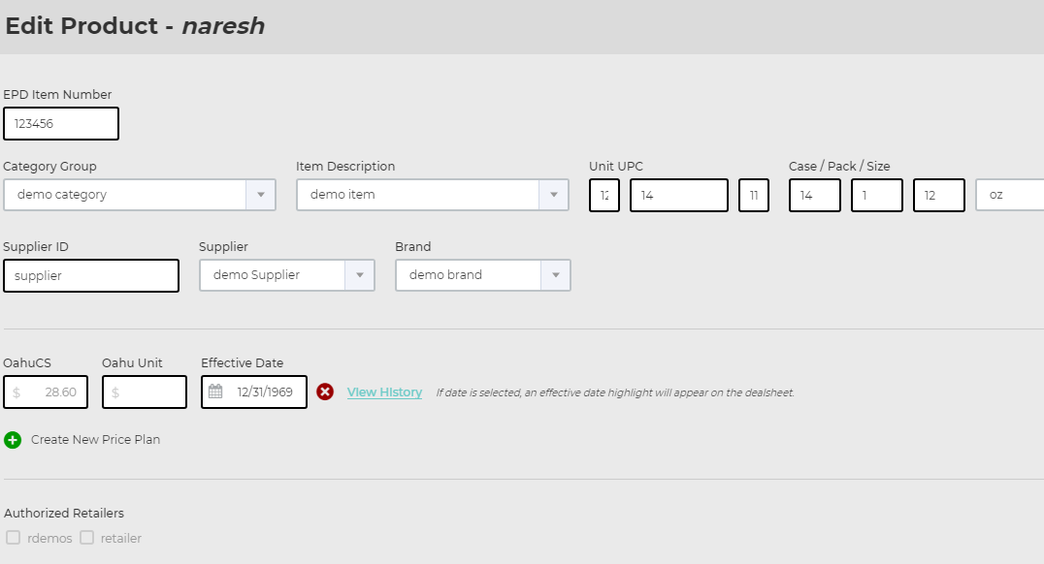

vi) validation not apply on the create product page

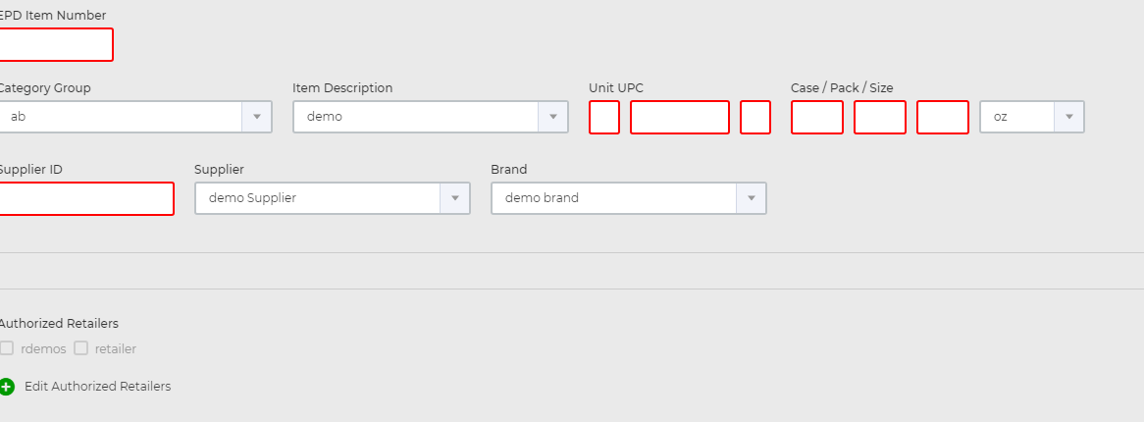

**12) Promotion page**

i) On allowance grid page 🡪 create new🡪dealsheet and product link is not working

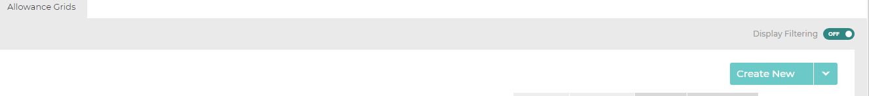

ii) batch action not define in the allows grid page in promotion page



iii) **)** Pagination is not working

